**GROUP MEMBERS:**

KHO, YUET HANG HILDA (105110) (hildakho@yahoo.com.hk)

TSOI, HIU YUI (105112) (andrew3687@hotmail.com)

AU, KA CHUN (105113) (akc971301@gmail.com)

|  |  |
| --- | --- |
| **Story Title** | **TOY BOY** |
| Journey Origin | I'm a wind up toy  In an up down world |
| Journey Destination | Tell him the story of a boy like me |
| No. of Moments | 6 |
| Text Segments | 1. I'm a wind up toy  In an up down world |
|  | 2. Come to life on a brass spring  Such a wonderful plaything |
|  | 1. But your momma thought  There was something wrong  Didn't want you sleeping  With a boy too long |
|  | 1. Toys are not sentimental How could i be for rental? |
|  | 1. I'm the sorest sight  Now I feel like trash |
|  | 1. Tell him the story of a boy like me |

**CONTENT STRUCTURE**

**VISUAL STRUCTURE - LINEAR MOTIF**

Journey Origin:

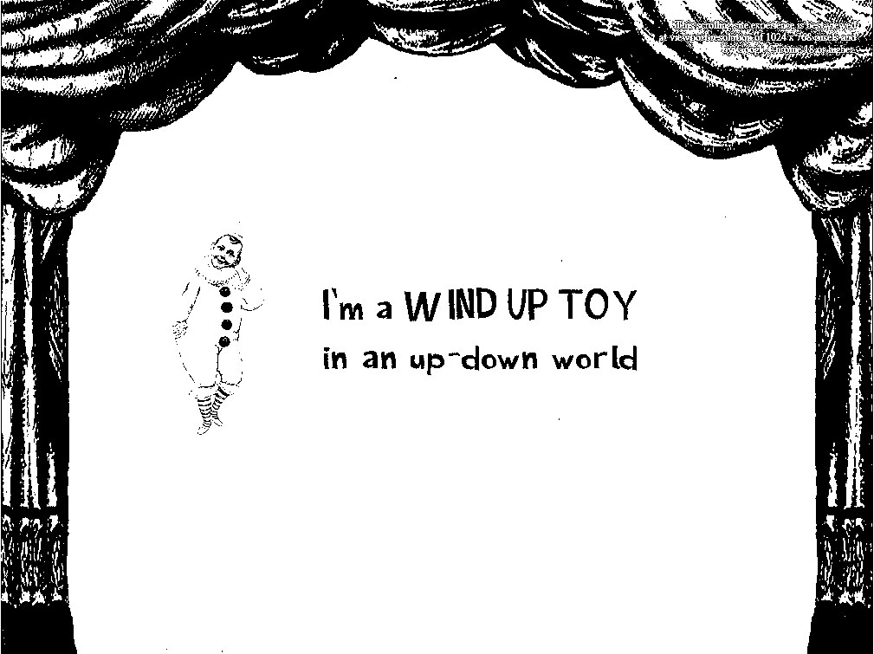

Journey Halfway:

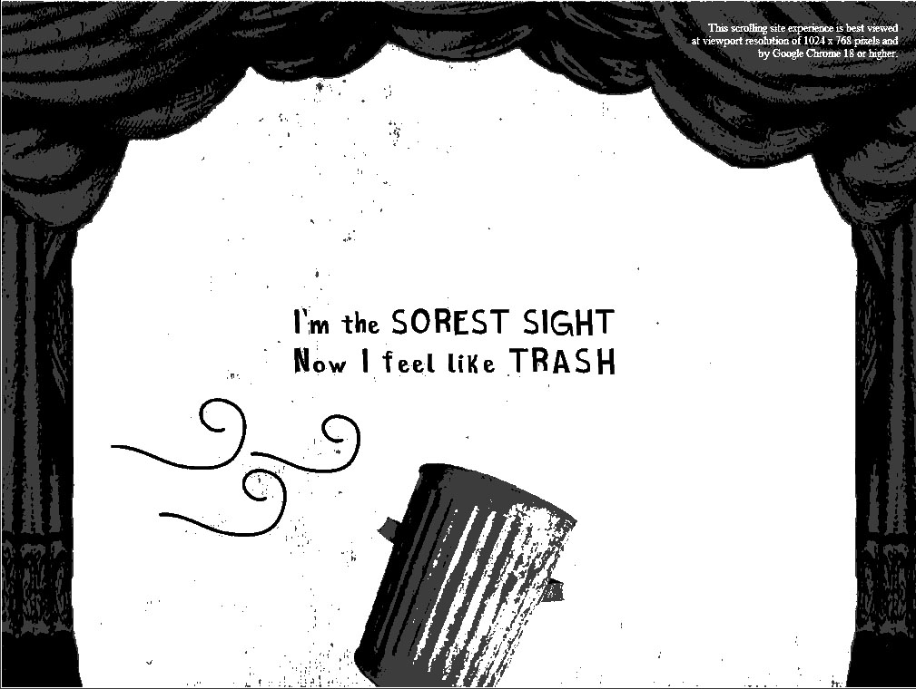

Journey Destination:

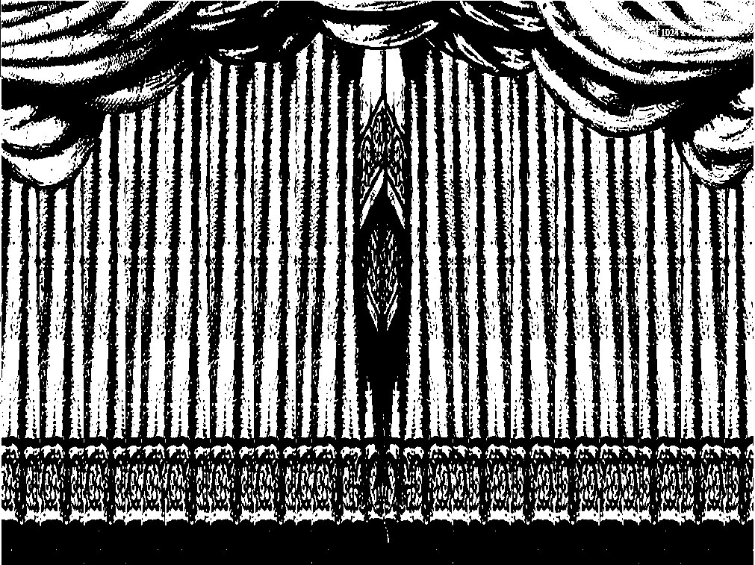

**VISUAL STRUCTURE - COLOR SCRIPT**

Journey Origin:

Journey Halfway:

Journey Destination:

**IMAGE TRANSITION – IDENTIFIED OBJECT**

|  |
| --- |
|  |